D2L Dropbox

Objectives:

- Identify dropbox capabilities in D2L.
- Create, edit and delete folders and categories in a dropbox.
- Set up a group assignment.
- View and evaluate student submissions.
- Grade anonymously to prevent unconscious bias.
- Enable and grade using annotation tool.
- Opt-in to the new dropbox experience.
Contents
Objectives: 1
Overview 2
What are Folders and Categories? 2
To Access the Dropbox tool: 2
Organizing a Dropbox 3
Creating Folders 3
Editing Folders 9
Deleting Folders and Categories 10
Group Assignment 11
Viewing and Evaluating Submissions 12
To access the Submissions Page 12
Evaluating Submissions 13
Evaluating Submissions with Annotations Tool 14
Student view of annotations 16
Anonymous Grading 17
New Dropbox Experience 19

Overview
The Dropbox tool in D2L allows you to see users’ submission times, download submissions, and return submissions with grades and feedback.
You can also restrict access to Dropbox folders by date and time, group membership, or special access permissions. There is no limit to file size, but the browser and internet speed can affect how large files are uploaded.

What are Folders and Categories?

Categories: Create categories to group and organize your Dropbox folders. For example, you can create a category called “Assignments” and have ten folders under this category (Assignments 1-10). You can also divide folders by weeks, units, etc., based on your course structure.
Folders: Create folders to organize assignments that students turn in to you.

To Access the Dropbox tool:
- Click on Assessments on the Main Navigation Bar and select Dropbox.
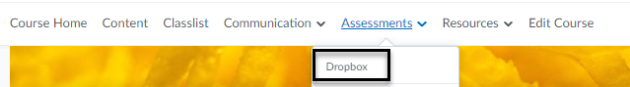
- You will be taken to the Dropbox Folders page where you can add and edit new folders and categories.

Organizing a Dropbox

Creating Folders

Adding Folders through the Dropbox Tool
- On the Dropbox Folders page, click on New Folder.
- Enter information in each tab (Properties, Restrictions, Objectives, Turnitin).
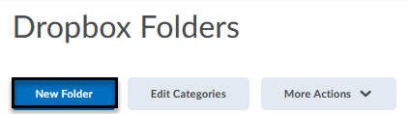

New Folder Page – Properties Tab

After entering a name and instructions for your folder, consider the following options:

- Attach a file link, existing course activity, share a document from OneDrive.
- Record a 30-minute maximum audio file for your students and upload a transcript. (The student will be able to save the audio file.)
- Select assignment type: individual versus group.
- One submission per group. You must first associate the Folder with a Group Category. Any group member can submit and view files for a group Dropbox Folder. See section on Group Assignment to learn how to create a category in the Groups tool under Communication.
- Click drop-down menu to change file type (Text, On Paper, Observed in person).
- Unlimited files allow for students to submit more than one file in case an error was made for the first attempt.
- Keep all submissions or only most recent one is recommended.
- Enter an email (optional) if you would like to receive an email each time a submission is uploaded to the dropbox folder.
- Category is used to organize folders. (Optional)
a. When you create a Folder that you want to organize under a Category, create the Category through the New Folder page. For other Folders in the Category, choose the Category name from the drop-down menu. Note: Categories can be deleted and sorted on the dropbox folder list main page using Edit Categories.
- Enter a score. This number should match the rubric score (grade item’s maximum points).
- Select an existing grade item from the drop-down menu or create a new grade item.
- Click the drop-down menu to Edit Display Settings for student view (only if associated with a grade item).
- Associate the Folder with an existing rubric or create a new one.
- Default points-based rubric only applies when a score is recorded for the folder and multiple points-based rubrics. Text-only rubrics do not show up in this list.
- Allow students to add this assignment to their ePortfolio. Note: The ePortfolio Artifacts tool is only available by IT services upon request.
- Anonymous Marking allows for grading anonymous submissions . Once published, the student names appear.
- Make annotation tools available for assessment is optional and found at the bottom of the list of the Properties tab.
- Save your work by selecting either Save and Close, Save and New or Save.

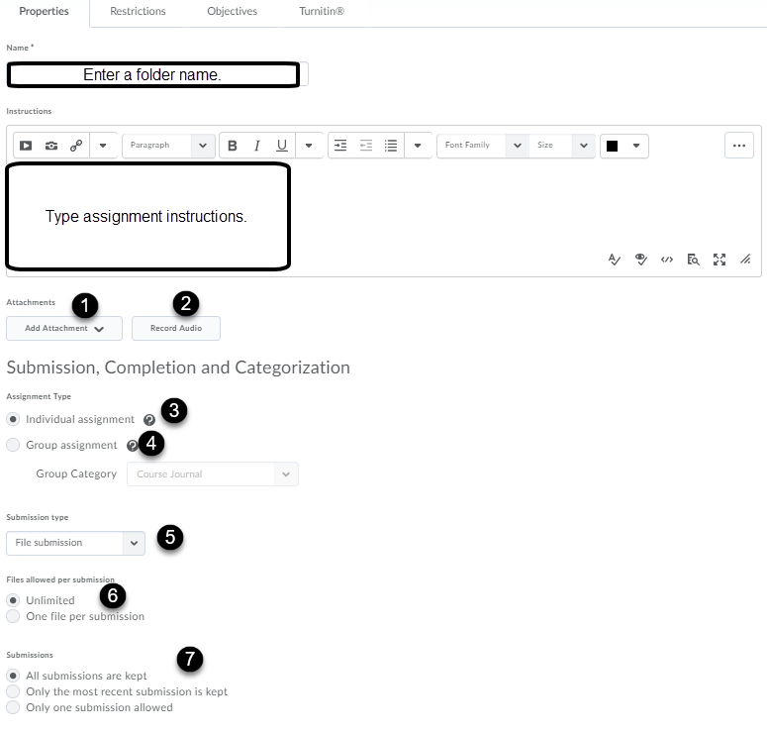

New Folder Page – Properties Tab (continued)
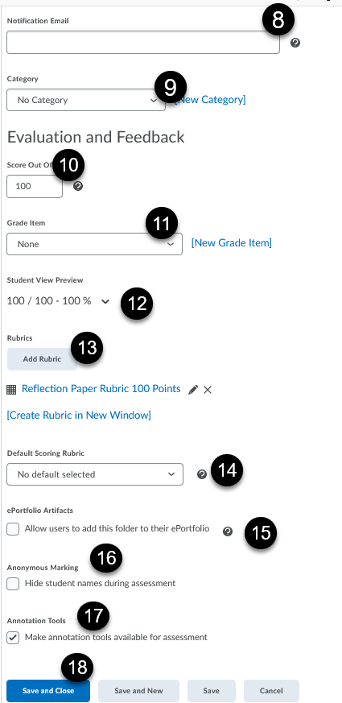

New Folder Page – Restrictions Tab
To edit availability of this folder, click on the Restrictions tab at the top of the New Folder page.
- If you are not ready to release access to students, click the “Hide from Users” checkbox.
- Entering “Has Due Date” flags late submissions and will populate the calendar.
- The “Has Start Date” opens student access to the dropbox folder.
- The “Has End Date” closes student access to the dropbox folder.
- (Optional) Establish Release Conditions: students must complete a task in D2L before having access to this Folder.
- To add specific student access to the folder, click on Add Users to Special Access. Check the names of the students you want to have special access from the enrolled student list.
- Click Save and Close, Save and New or Save.

Restrictions Tab
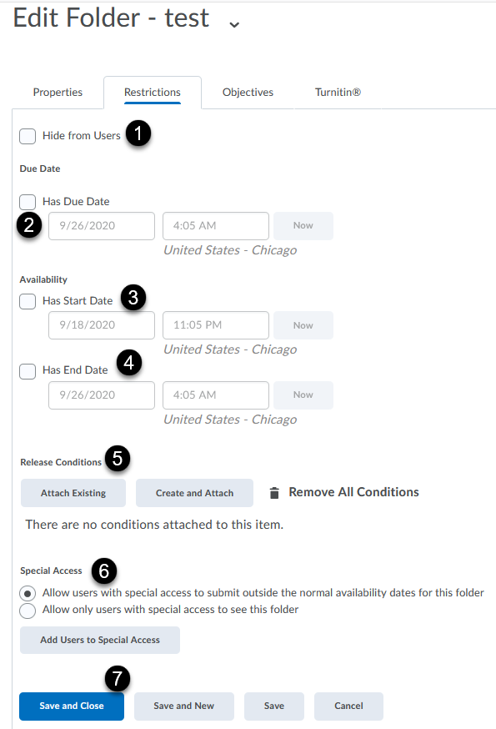
New Folder Page – Turnitin Tab
- To detect plagiarism, enable the Turnitin integration by clicking the Turnitin tab and check the box next to the Enable GradeMark for this folder option which lets you add inline text, comments and highlight sections in file submissions.
- Where there are multiple submissions, the score on the most recently submitted assignment will be transferred.
- GradeMark must first be enabled to check this option. Originality Check detects plagiarism.
- Click the checkbox to allow students to see the report generated by Turnitin.
- Select whether originality report is generated for all submissions or only identified submissions.
- More Options in Turnitin. See page 8 for further details.
- Save and Close, Save and New or Save.

Turnitin Tab
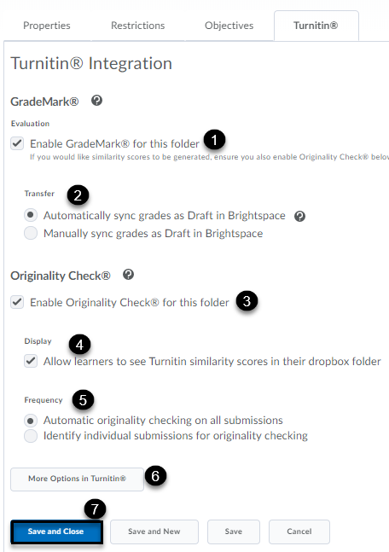

More Options Turnitin Settings (continued)

The Submission settings comes with default settings as indicated above. It is also recommended to select the above indicated items, 1-4.

- The grammar checking tool (e-rater) will provide the student feedback on grammatical errors.
- Allow students to view the Similarity Report and check exclude bibliographic materials, quoted materials and small sources.
- Save the settings as your default for future assignments.
- Click Submit button.

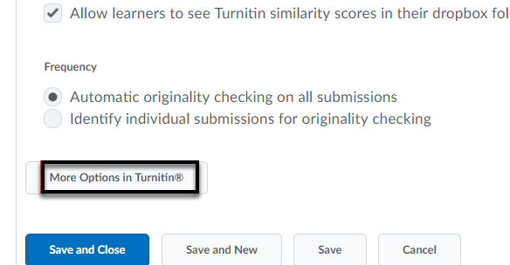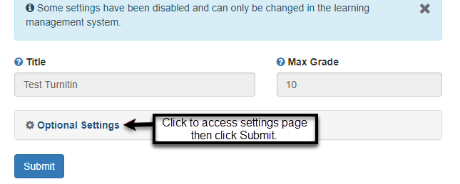

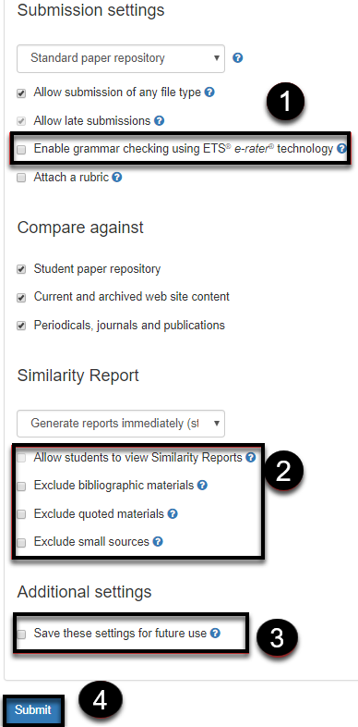

Adding Dropbox through the Content Area
- Click on Content on the Main Navigation Bar.
- Click on the module where you would like to add your Dropbox.
- Click on New and select New Dropbox from the drop-down menu.
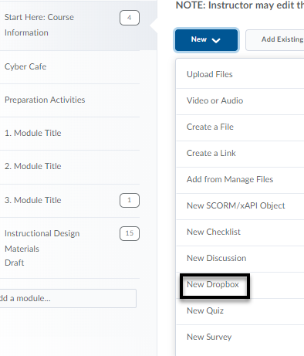
- Enter all the information in the Create a Dropbox Folder page. Note: The dropbox is published automatically after clicking the Save button.

- Add an existing dropbox to your module by clicking Add Existing Activities. Then, select the Dropbox folder.
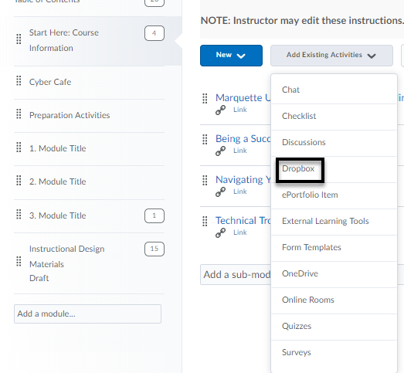

Editing Folders

- From the main toolbar, click the Assessments tab and select Dropbox.
- On the Folders Page, click on the drop-down menu next to the name of the Folder you want to edit.
- Select Edit Folder from the drop-down menu.
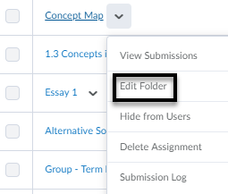

- Make your changes.
- Click Save.

Deleting Folders and Categories

- From the main toolbar, click on the Assessments tab and select Dropbox.
- Select the dropbox(es) that you would like to delete from the list or select all by clicking the top checkbox. [1]
- On the Folders Page, click on More Actions and select Delete from the drop-down menu.
- Click on the Delete button again to confirm the selection. [2]
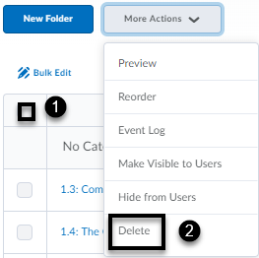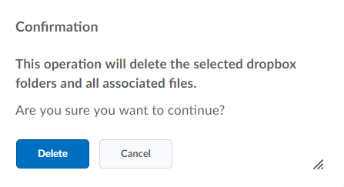
Note: When you delete all the folders in a category, the category will be deleted as well.

Group Assignment

Use Groups to design work areas for students to discuss, share and submit work as a group. Before a group assignment type is selected under the Properties Tab, create a group under Communication > Groups > New Category.
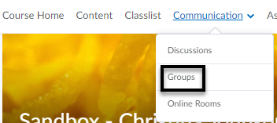
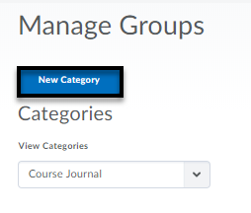
- Enter a Category Name for the group.
- Enter a description (optional).
- Select Enrollment Type which is defined on how students are enrolled and how many groups are created. Enter number of students to a group. Note: Number of Users and Advanced Properties options are available upon Enrollment Type selection. The auto-enroll and randomize user options are available under Advanced Properties.
- By default, no restrictions option is selected for Restrict Enrollments To menu (optional). This allows for subgroups based on section or group enrollment.
- Create a discussion, locker or dropbox folder or create it under that specific tool and associate it to your newly created group by selecting the Group Category menu.
- Click Save.

Viewing and Evaluating Submissions

To access the Submissions Page

- Click on Assessments from the main tool bar and select Dropbox.
- Select a folder to view by clicking the drop-down menu next to its name and clicking View Submissions.
- View by User or Groups by clicking drop-down menu and then click Apply or magnifying glass.
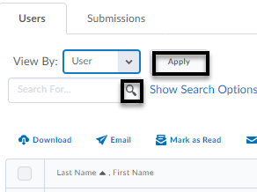
- The toolbar selected below allows for download of submission, student email, marking submission as read, marking submission as unread, deletion of submission and publishing feedback (once the checkbox has been selected next to the dropbox folder).
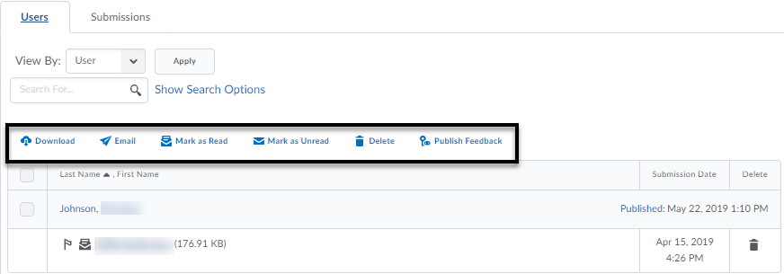

Evaluating Submissions

- On the Folders Page, select the folder you want to evaluate. You can either click the student’s name, Group name, or click on Evaluate.
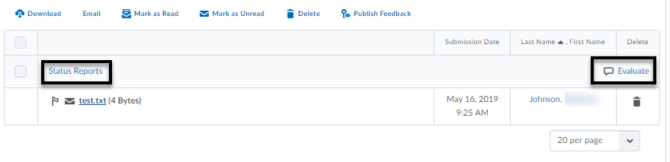
- Once in the Submissions Page for the Folder, click on the assignment link for the student you wish to evaluate.
- You will be taken to the Evaluate Submission page where you can view the assignment online with the document viewer or download it to work offline.
- The Evaluate Submission page also has an Evaluation and Feedback panel to the right of the document viewer. The panel provides the student’s information and areas for you to grade and provide feedback.
- Once the evaluation is completed for each student, click on Save Draft. Note: If rubric is used to score, it is not necessary to enter a score in the field. Click the arrow in the upper right-hand corner to evaluate next student. Click Back to Folder Submissions to Publish all Feedback once grading is complete.
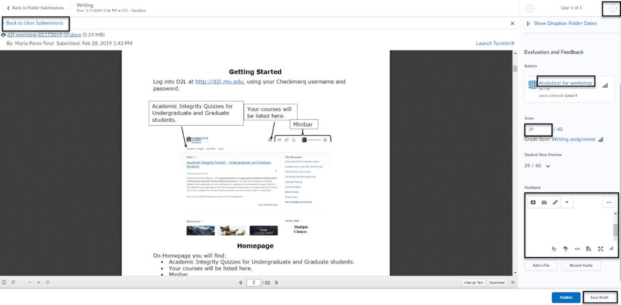
Evaluating Submissions (continued)
- The instructor view of the dropbox folder list shows the number of assignments completed, evaluated and feedback published as well as the due date for each assignment. The icon to the right of the submission name shows it is tied to the grade book.
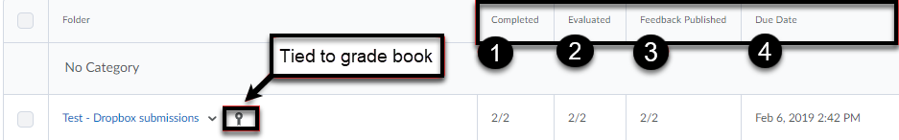
Note: Grades entered in the gradebook will update the score in the dropbox.

Evaluating Submissions with Annotations Tool
The annotations feature is a visually based grading feedback tool. It will need to be enabled under the Properties tab to be able to access the toolbar. To delete an annotation, click on the icon in the document and select delete button on the keyboard. Note: Assistive technologies may have difficulty reading annotations.
Drawing/Highlighter (freeform and text) and Eraser are located under the Marker icon.
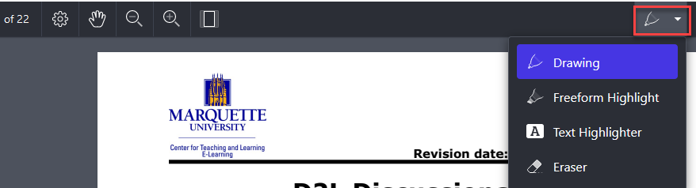
Colored comments (sticky notes), right pointer, comment with checkmark, comment with circle (ellipse), comment with x (cross), comment with insert text, comment with new paragraph left pointer, comment with text note, comment with paragraph, comment with question mark (help), comment with star, comment with key are located under the Note icon.
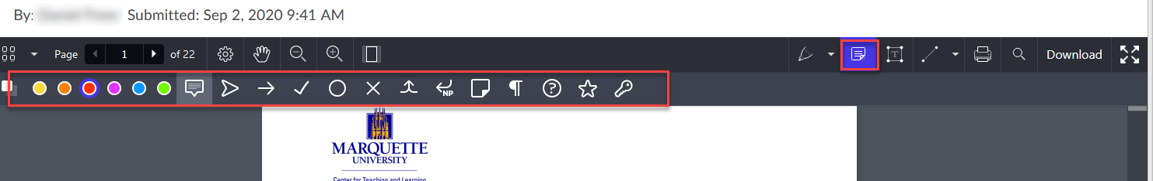
Color options for text and background in text box along with options for font style and size and left, right, center justification are located under Text box icon.
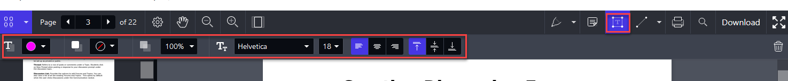
Line, arrow, rectangle options found under the Line icon.
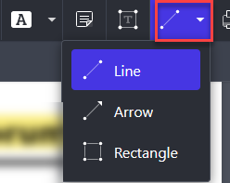
The annotations (i.e., icons selected) will appear on the document, but the student will need to hover or click on it to view the comments.
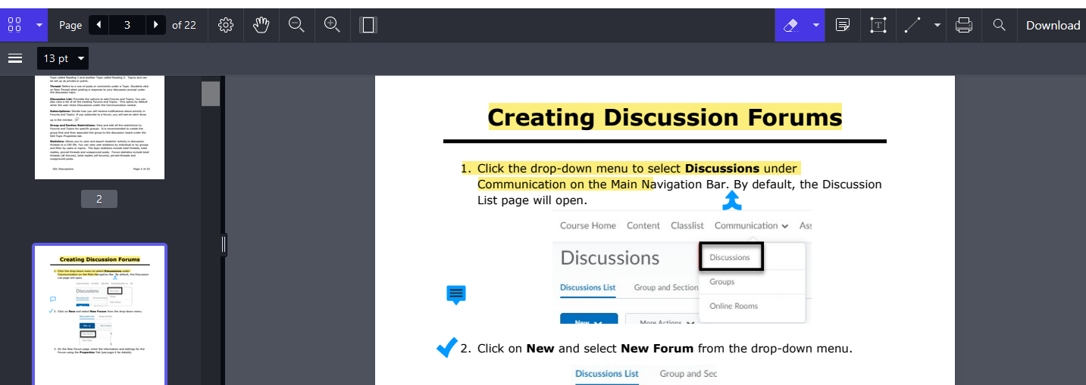
Student View
- The student view of the dropbox folder shows the due date, whether an assignment was submitted, scored, and feedback has been read or unread.
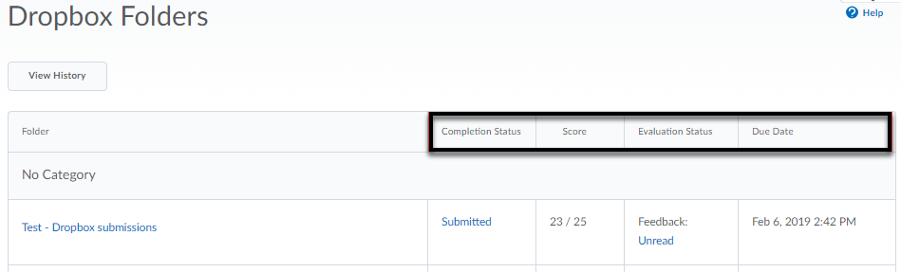
- The student has access to view all submissions under View History and clicking the drop-down menu to select the folder to view individual assignments.
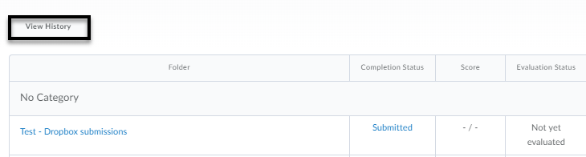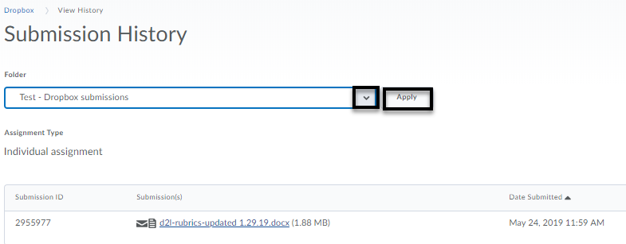

Student view of annotations

The student will click Unread link under Evaluation Status in Dropbox Folder list and select View Inline Feedback.

Anonymous Grading

Note: Once anonymous grading is enabled, visibility of student names cannot be modified after submissions exist.
Dropbox submission anonymous grading:
- Under the Properties tab of the New Dropbox Folder, select Hide student names during assessment. Click Save and Close.
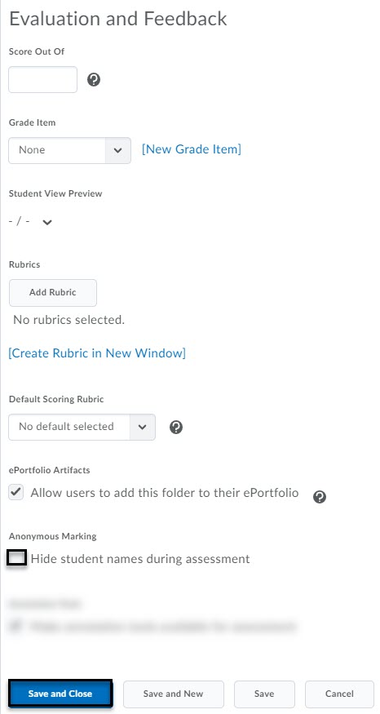
- The dropbox folder list should have an Anonymous Grading enabled icon next to dropbox folder name.
- The Evaluate page should only display Anonymous User Number in place of the student’s name.
- Provide feedback [1]and score [2]. Save draft [3] and continue to grade each student [4]. Click Back to Folder Submissions [5].
- Once all the submissions are graded, click Publish All Feedback. The student names will become visible once the grades are published.
- Click Yes to confirm publishing.
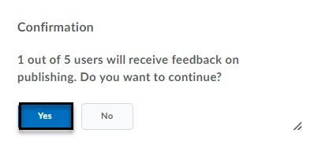
- Student’s name appears and Draft Saved now appears as Published.
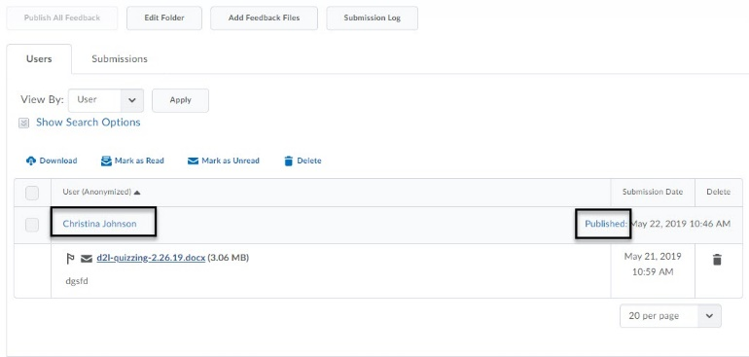

New Dropbox Experience

A new dropbox experience is available by clicking the drop-down arrow located in the upper right-hand page after clicking New Folder.
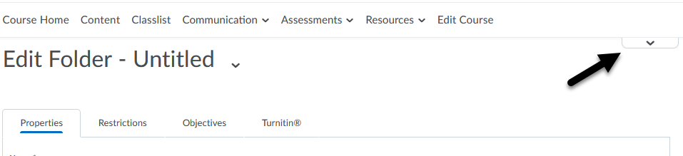
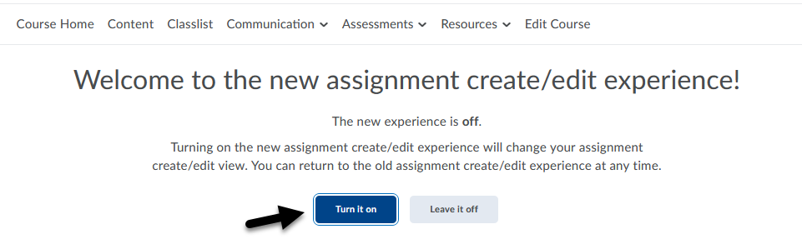

Dropbox Details
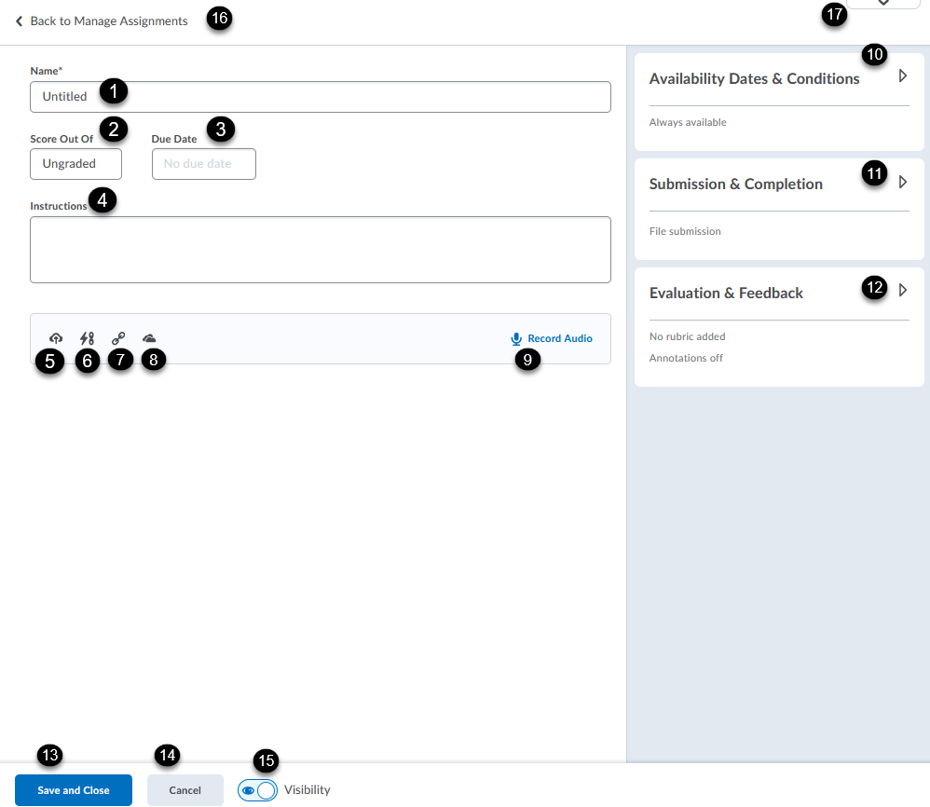
Enter title of dropbox folder [1].
Enter a score. If left blank, the dropbox will be ungraded [2].
Enter a due date [3].
Enter instructions [4].
Attach a file [5].
Attach a link to an existing activity (e.g., dropbox, discussion, quiz) or course files [6].
Attach a URL (weblink) [7].
Attach a document from OneDrive [8].
Record a one-minute audio and add a transcript [9].

Availability Dates & Conditions
Expand the right arrow to enter availability dates, release conditions and special access [10].
Submission & Completion
Expand the right arrow to enter an email for notification when an assignment is submitted (optional), assign individual versus group assignment type, select submission type (file, text, on paper, or observed in person), select submissions (all are kept, only one, or only most recent submission) [11].
Evaluation & Feedback
Expand the right arrow to add a rubric, manage learning objectives, enable annotation tools, anonymous marking, and manage Turnitin [12].

Save and Close to return to the Dropbox folder list [13].
Cancel returns user to Dropbox folder list without saving [14].
Use the toggle button to hide or make visible the dropbox folder [15].
Back to Manage Assignments returns user to dropbox folder list [16].
Drop-down arrow to toggle back to previous dropbox experience [17].

