Edit Captions on Microsoft Stream Videos

- Navigate to the video you want to edit. As long as you are the owner of the video you will have these editing capabilities. 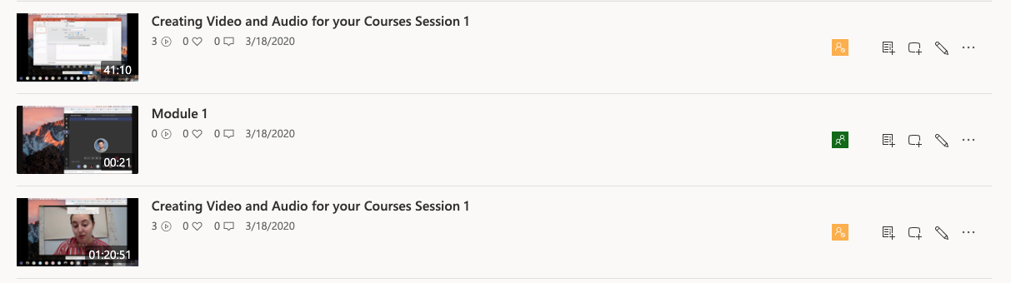

- You will see the Interactive Transcript next to the video. To edit you will click the EDIT TRANSCRIPT button (indicated as a pencil icon). 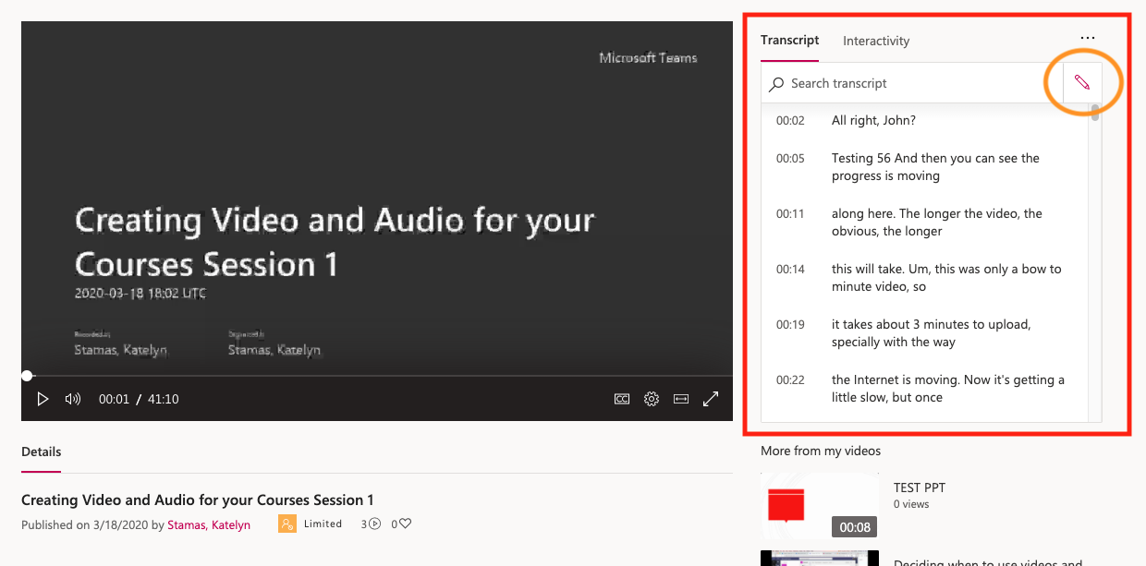

- Now you can edit each section that was captioned. As you select each one it will navigate to where in the video that caption plays. 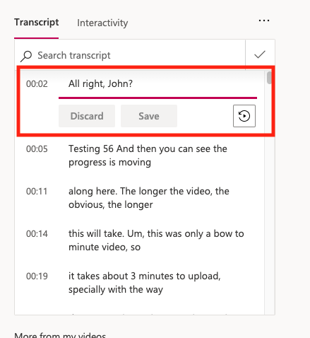

- Anytime you make a change you must click the SAVE button under each caption section. 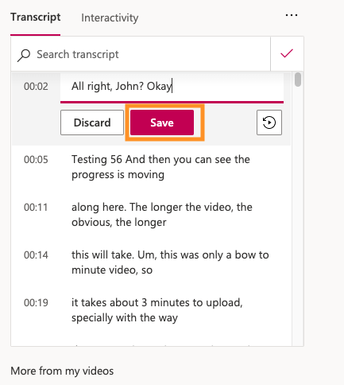

- When you are done select the VIEW TRANSCRIPT button which is the same as the edit button (now indicated as a check mark icon). You are now viewing your video and other views will see your updated captions. 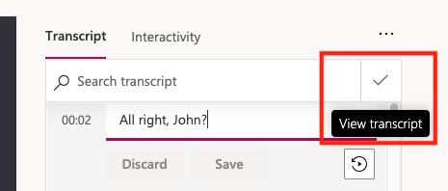

It is important to note that while the captioning that occurs on Microsoft Stream is automatic, it is NOT 100% accurate. Due to the nature of how it is captioned the computer only picks up so much of what is being said correctly and in order to ensure that students who rely on captions are getting the full use of your videos, it is important to go through and make the transcript as accurate as possible.

