Inserting Recorded Videos into a Narrated PowerPoint

Overview:
This guide is aimed at both Mac and PC users. After you have recorded all of the narration for your PowerPoint presentation you may want to insert a separate video you recorded into the presentation so it can all be exported as one file. The steps to do so are very simple.

Instructions:
- In your presentation go to Home in the PowerPoint tabs and add a New Slide in the locations of your PowerPoint that you want to insert other videos. This can be the first slide, throughout the presentation, or the last slide.

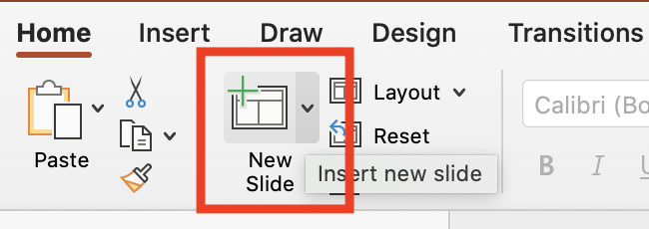

- Once you select New Slide, a series of options will appear for the different types of slides that can be added. It is best practice to select the “Title and Content” option.

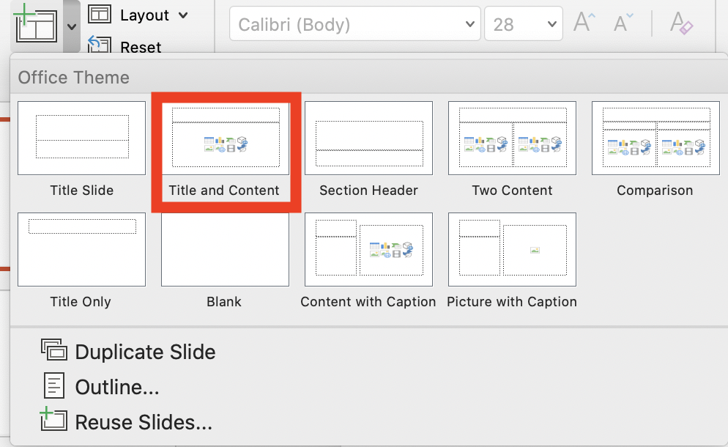

- In the add text section of the slides are a series of icons. You will select the Insert a Movie from File icon (the film reel on the bottom row, second to last).

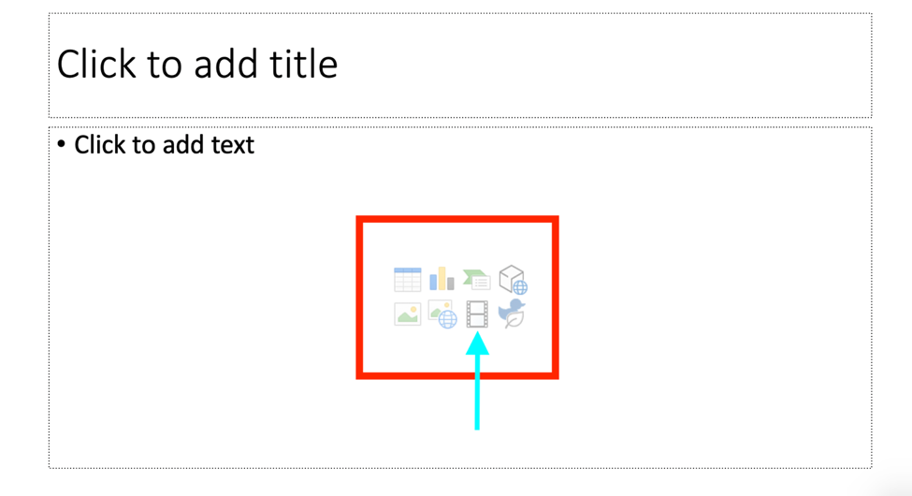

- A file window will appear and you will be prompted to locate the video file you are going to insert into the slide (this can be an MOV or MP4 file). Once you have found the video select it and click Insert in the lower right corner of the window.

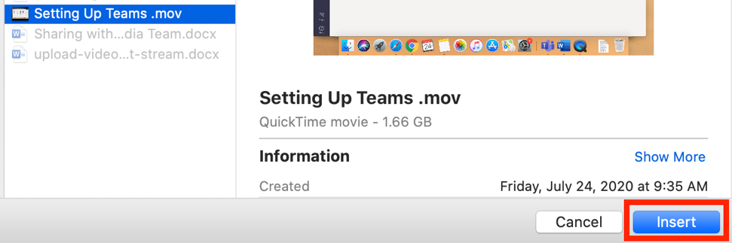

- The video will be inserted into the slide along with a play button to view the video at the bottom. On each of the four corners of the view will be small boxes which will allow you to resize the video to fit the slide on the top and bottom.

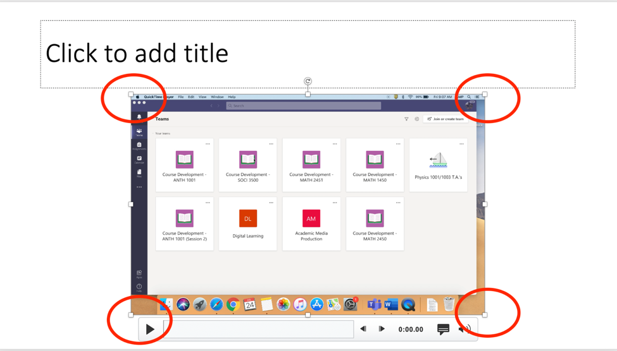

- It is best practice to fit the video to the PowerPoint slide by dragging from one of the corners and readjusting the position from there to not stretch the image.
  - The video size will often not fit the entire slide and leave blank space on the left and right side of the slide. This is normal and helps to not distort the video size.

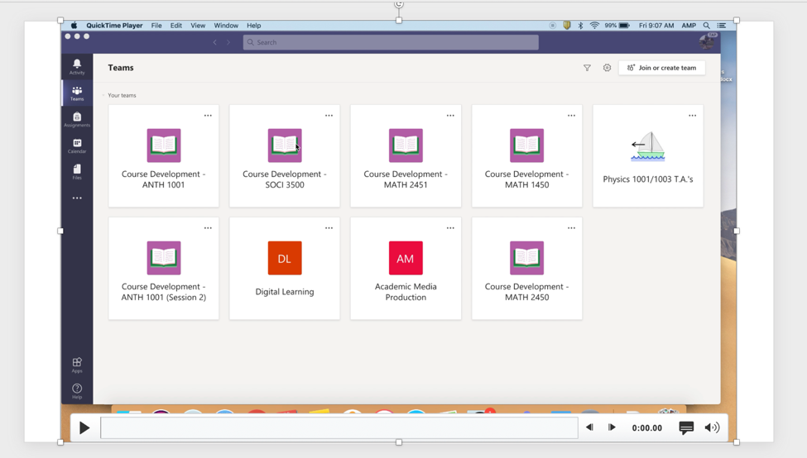

- Once the video is positioned how you like, you can follow the next steps to export your entire narrated PowerPoint, including inserted videos, as one video altogether. Those directions can be found in the guides on Creating a Narrated PowerPoint (for MAC or PC).

Here are some Best Practice Tips when recording videos (some options vary):
- Make sure your laptop setting have the camera and microphone enabled
- Turn off notifications on your laptop, otherwise it will show up in the video
- Record in a quiet room and avoid outside interruptions
- When on camera:
  - Use a room with adequate lighting- don't film in front of a bright window and make sure your face is lit up (so no filming in an extremely dark room)
  - Keep your clothing in mind- be careful of what words or phrases that may be on your clothing
  - Check the room- make sure there is no inappropriate content in the background
- If recording on a cellphone always record Horizontally and not Vertically.
- Try and keep your videos to under 10 minutes as this will save on processing and upload time when you’re creating the videos as well as when you add them to Stream. If your content takes longer than that then consider splitting up your presentations into a few parts.

