About the Database

Ethnic NewsWatch provides full text articles from newspapers and magazines published for ethnic communities in the U.S. It includes publications for African Americans, European Americans, Hispanic and Latino Americans, Native Americans, Asian Americans, Jewish Americans, and Arab Americans.

Basic Search Example

To demonstrate how to do a basic search in Ethnic NewsWatch, we will search for articles in Spanish relating to the health of immigrants. Our search terms will include the Spanish words salud (health), inmigracion (immigration) and inmigrante (immigrant).

STEP 1: Beginning the Search

After clicking a link to the Ethnic NewsWatch database, you should see a screen that looks similar to the one below. To start our search, we would complete the following four steps:

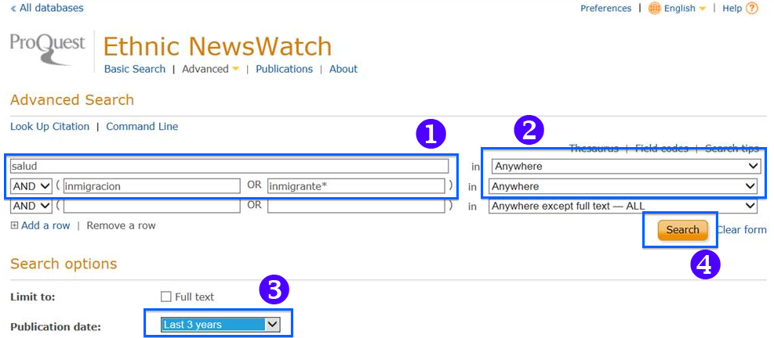
Click the Search button to start the search.
In this example we will use the Publication date limiter to search only articles published within the last 3 years.
From the drop down menus select Anywhere. By choosing this option, the database will search for our terms in all parts of the record including the full text. Selecting this option will ensure the return of as many results as possible.
Enter the search terms, salud, inmigracion, inmigrante into the search form fields. Note the asterisk at the end of inmigrante. The asterisk is a commonly used wildcard symbol that broadens your search. It will retrieve variations on a distinctive word stem or root.

STEP 2: Viewing Search Results

On the search results screen you can see the number of relevant items found. The database will highlight your search terms within the title and parts of the full text of the article. You can also change your search terms in the search form field at the top of the page.

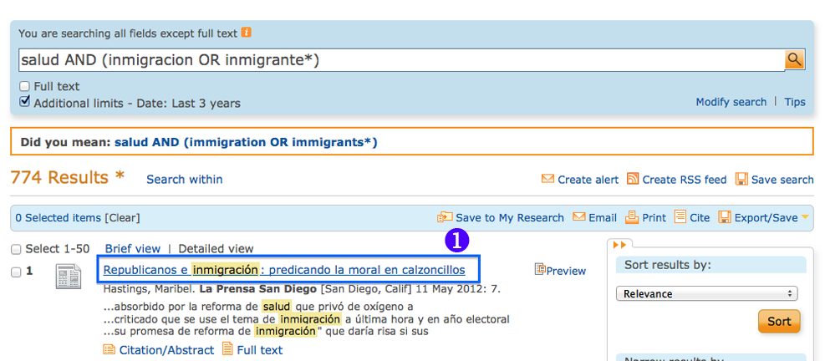
To view the full text of an article, click the article title.

STEP 3: Printing or Emailing an Article

From the full text version of the article you can you can print or e-mail it to yourself for future reference. You can also return to the search results list or go back and change your search.
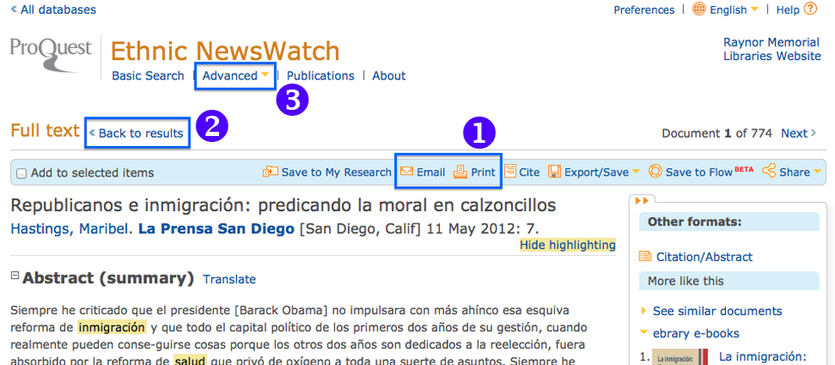
Clicking the Advanced will return you to the search screen shown in Step 1, allowing you to adjust or edit your search terms and limiters
Back to results will return you to the search results page.
Click the Print or Email links to save a copy of the article for future reference.

