MUEngage for Faculty Members-Quick Guide
Marquette’s new community engagement tracking system for community service, service learning, and more!

MUEngage is the new community engagement tracking system for Marquette University. Within the Service Learning Program, MUEngage replaces the in-person sign-up night. Students can now sign-up for service learning online, record their impacts (i.e. service learning hours, projects, and presentations), and register for reflection sessions. Faculty members can also see impact hours for students and print course summary reports at the end of the semester. This Quick Guide was designed for faculty members to navigate MUEngage. Faculty members can contact the Service Learning Program for more detailed instruction and one-on-one assistance.

Checking Service Learning Hours:

When you log in MUEngage, under MANAGE (in the top bar), select YOUR COURSE. You should see the screen below (with the name of your course):

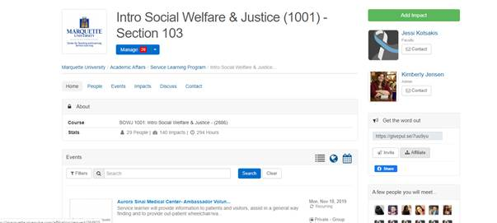

On the left hand pane, click the down arrow next to USERS and select MANAGE USERS. You should see the following screen:

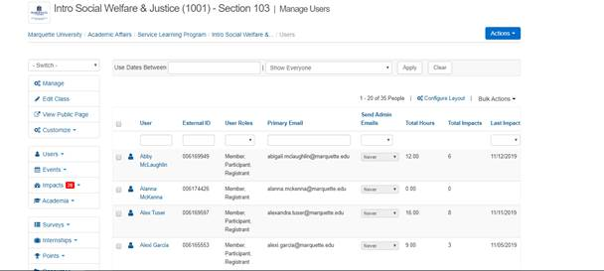

Go to the blue ACTIONS and click the down arrow. Select COURSE SUMMARY REPORT. You should see the following screen:

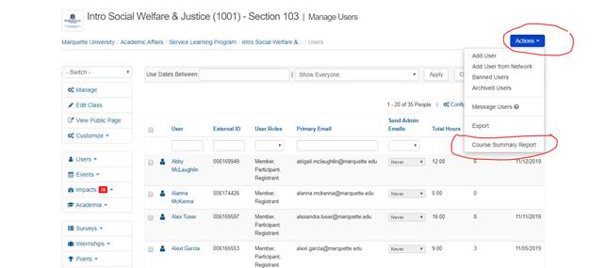

Select which format you want the summary report: pdf or csv. This report is for you, so choose your preference. You should see the screen below:

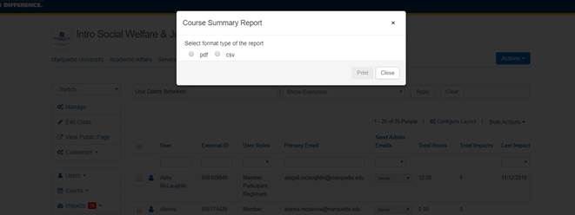

Once you make your selection. You should see a pdf or excel document. Below is an example of a PDF document:

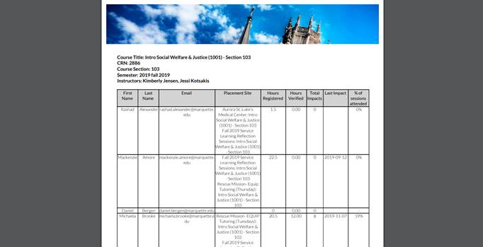

Checking Attendance for Reflection Sessions:

When you log in MUEngage, under MANAGE (in the top bar), select YOUR COURSE. You should see the screen below (you should see the name of your course. The screen below is an example).

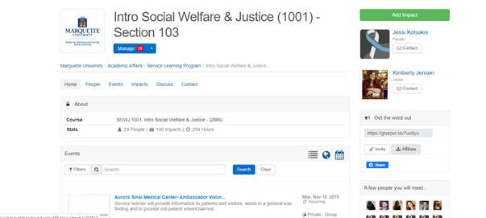

Or you should see the following screen

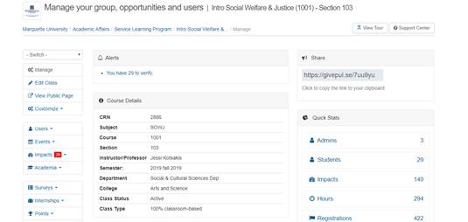

On the left hand pane, click the down arrow next to EVENTS and select MANAGE REGISTRATIONS. You should see the following screen:

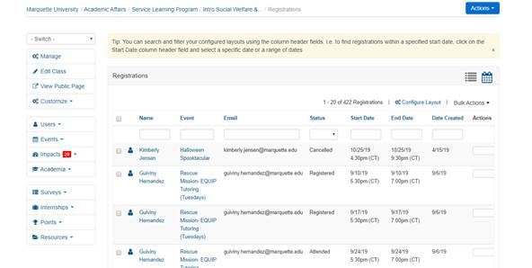

You may see students that are not in your class-please don’t be alarmed. If students sign up for events (i.e. sites) not listed for their course, they will show up in the course for where the event is listed. Just disregard the people who are not in your class.

In the Event section, you can filter down to Fall 2019 Service Learning Reflection Sessions or current semester and year (e.g. Fall/Spring-Current Year). Start typing FALL 2019 SERVICE LEARNING REFLECTION SESSION. See below:

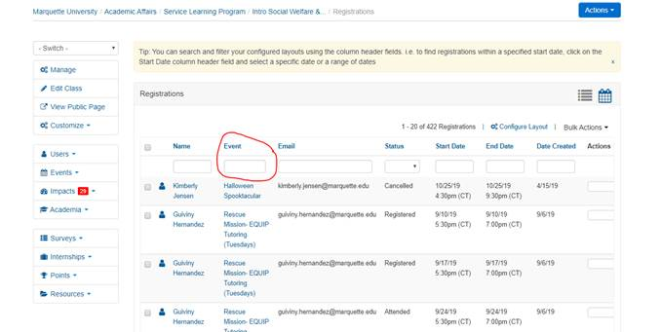

You should see the following screen:

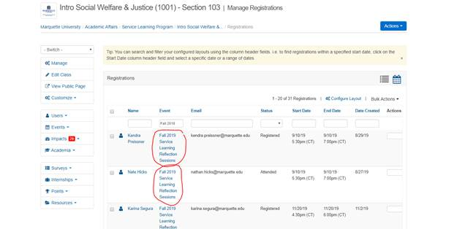

You can go through the list to see the reflection sessions your students attended. You want to make sure it says ATTENDED (i.e. just because they registered for the reflection session does not mean they attended the registration) next to their name. You can also look for the specific date of the reflection session they attended by looking at the START and END date.

